Experiment No.: 4

Title: Functional Testing using Selenium

Batch: B–1 Roll No.: 16010422234 Experiment No.: 4
______________________________________________________________________________

Aim: To perform functional testing using Selenium.
______________________________________________________________________________

Resources needed: Internet, Firefox Browser, and Selenium IDE
______________________________________________________________________________

Theory:
Selenium is a portable software-testing framework for web applications. Selenium provides a playback (formerly also recording) tool for authoring tests without the need to learn a test scripting language (Selenium IDE). It also provides a test domain-specific language (Selenese) to write tests in a number of popular programming languages, including C#, Groovy, Java, Perl, PHP, Python, Ruby and Scala. The tests can then run against most modern web browsers. Selenium deploys on Windows, Linux, and macOS platforms. It is open-source software, released under the Apache 2.0 license. Web developers can download and use it without charge.

Selenium IDE is an integrated development environment for Selenium scripts. It is implemented as a Firefox extension, and allows you to record, edit, and debug tests. Selenium IDE includes the entire Selenium Core, allowing you to easily and quickly record and play back tests in the actual environment that they will run in.
Selenium IDE is not only a recording tool: it is a complete IDE. You can choose to use its recording capability, or you may edit your scripts by hand. With auto complete support and the ability to move commands around quickly, Selenium IDE is the ideal environment for creating Selenium tests no matter what style of tests you prefer.

Features:
- Easy record and playback
- Intelligent field selection will use IDs, names, or XPath as needed
- Autocomplete for all common Selenium commands
- Walk through tests
- Debug and set breakpoints
- Save tests as HTML, Ruby scripts, or any other format
- Support for Selenium user-extensions.js file
- Option to automatically assert the title of every page
______________________________________________________________________________

Procedure:
1. Install Selenium IDE.
Step1 - Launch Firefox and navigate to
https://addons.mozilla.org/en-US/firefox/addon/selenium-ide/. Click on Add to Firefox.
Step2 - Click on Add Button to Give Permission.
Step3 - Launch Selenium IDE Click on Selenium Icon appear on the right hand side of the address bar.

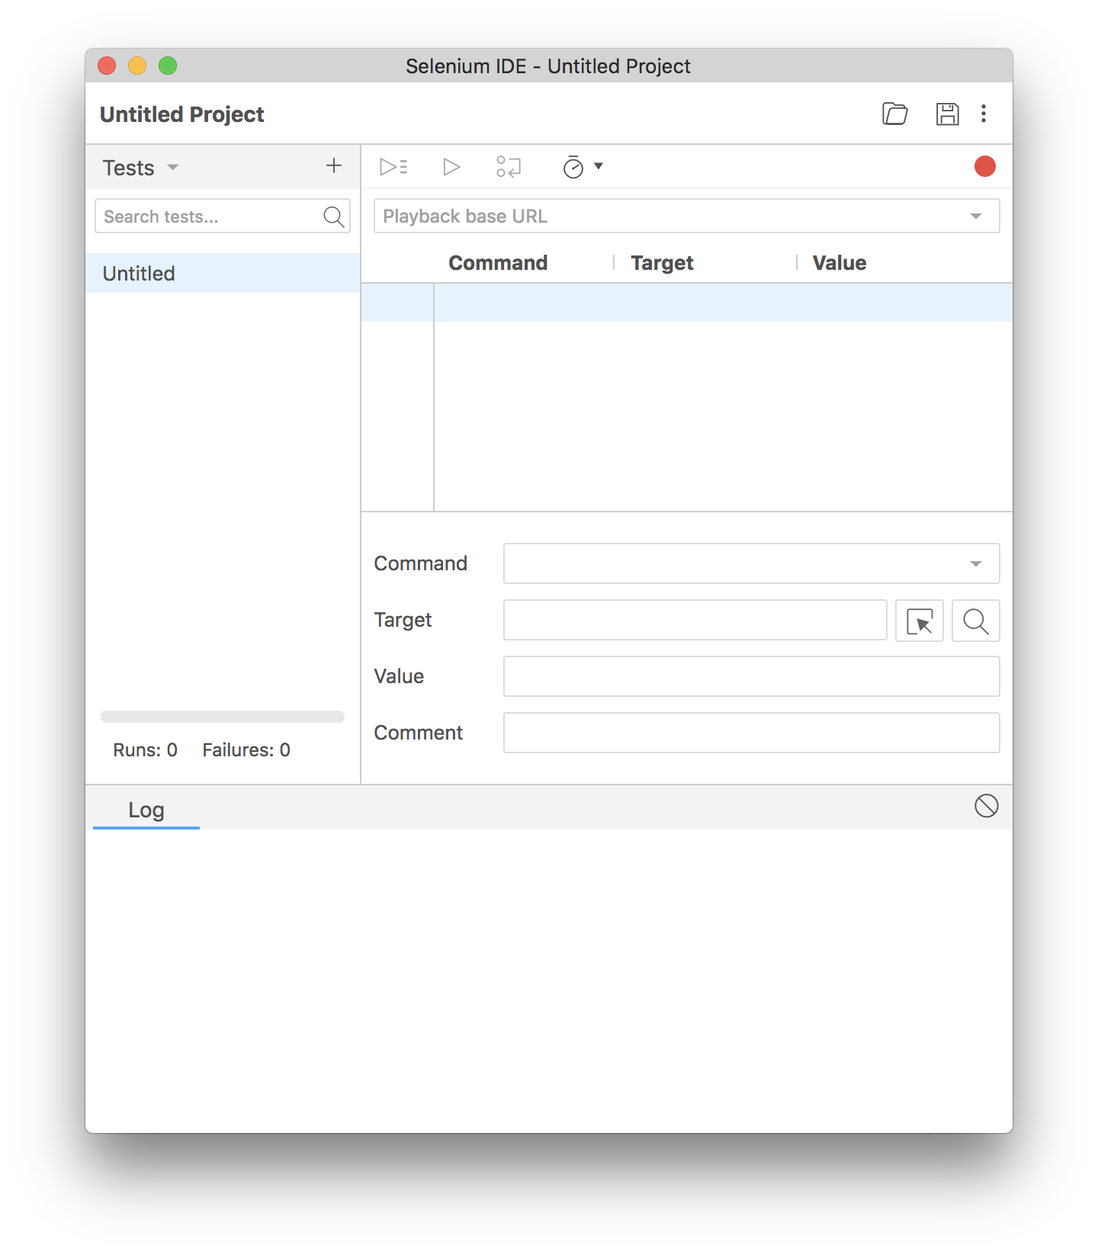
2. Open any Website (under test) on Firefox -
For example: http://automationpractice.com/index.php

3. Document and Implement the following Features:
- Auto Scripting and Playback
- Verification
- Assertion
- Store Variables

Note: Since Selenium IDE is Firefox based extension we need to Install Firefox
https://www.mozilla.org/en-US/firefox/57.0/releasenotes/
______________________________________________________________________________

Results: Snapshots of Script and log

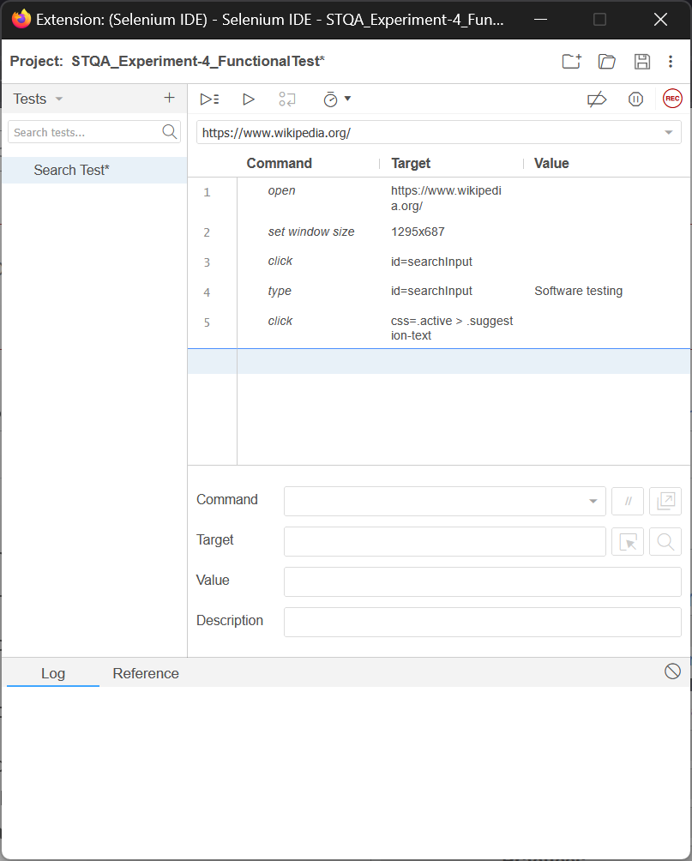
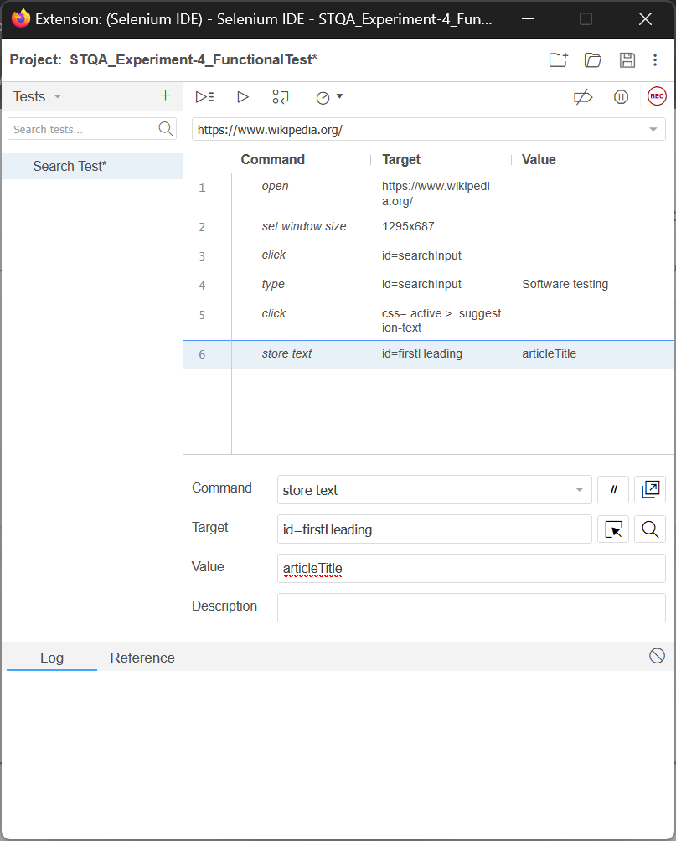
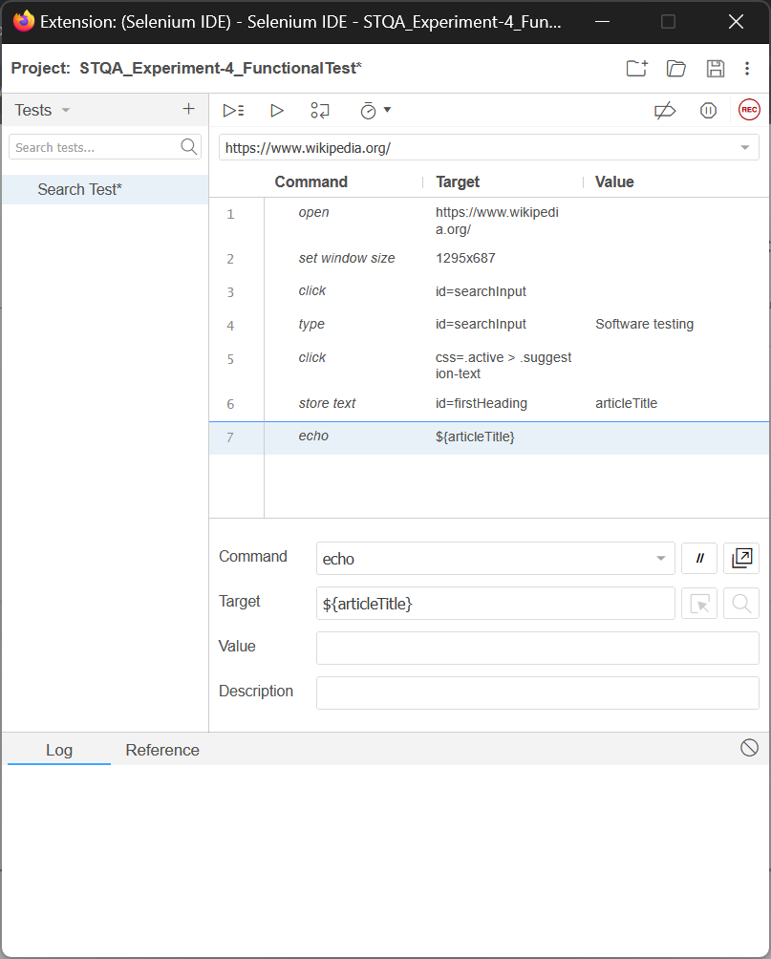

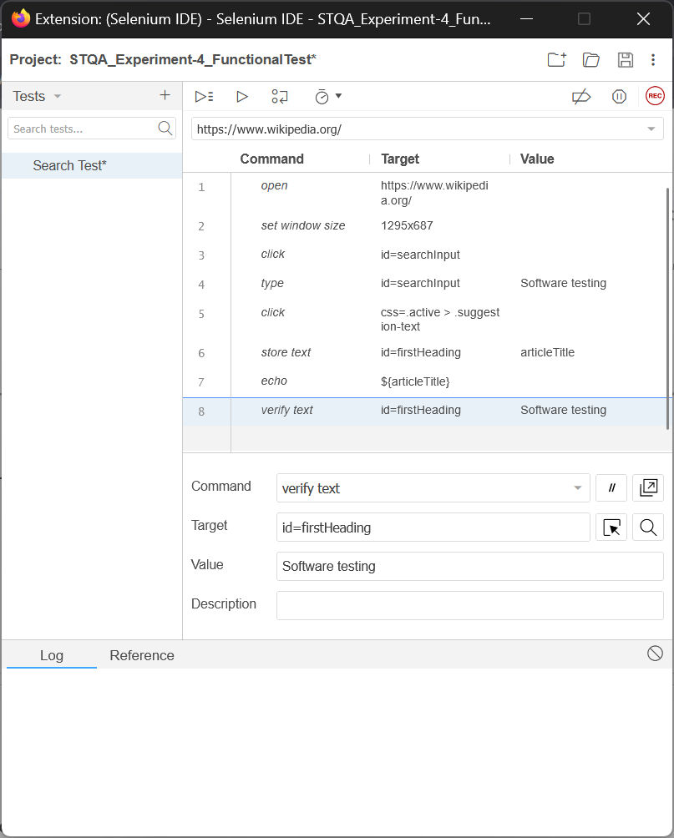
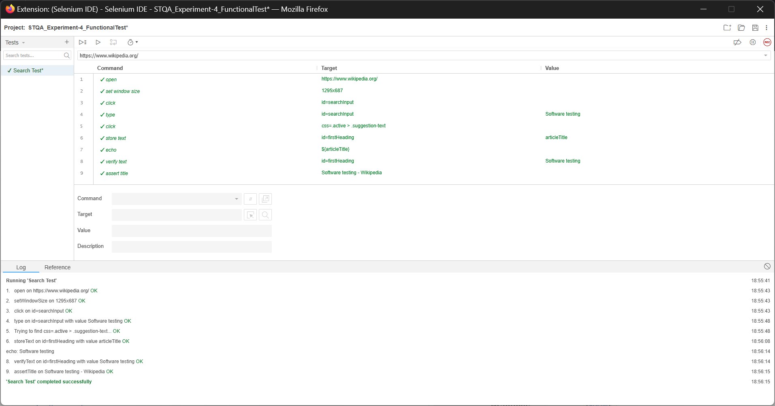
______________________________________________________________________________

Questions:

1. Explore one additional feature of Selenium not listed in the write up. Document and implement it.

Ans: An additional powerful feature of Selenium IDE not listed in the write-up is Control Flow Logic, which allows for creating more intelligent and adaptive tests using commands like if, else, end, and while.

- Documentation:
Simple record-and-playback scripts follow a linear path and will fail if the application's state is not exactly as expected. Control Flow Logic allows a test script to make decisions. For example, a test can check if an element is present on a page and perform a different set of actions based on the result. This is crucial for testing dynamic websites where content can change. The main commands are:
- if / else if / else / end: Executes a block of commands only if a certain condition is met.
- while / end: Repeats a block of commands as long as a condition is true.
- times / end: Repeats a block of commands a fixed number of times.

- Implementation Example (Using if/end):
Let's imagine a test scenario where we want to log out a user only if they are currently logged in. We can check for the presence of a "Sign out" button.

Website: http://automationpractice.com/index.php
Scenario:
- Go to the website.
- Check if the "Sign out" button is visible.
- If it is visible, click it.
- If it is not visible, the script does nothing and ends.

Selenium IDE Script:

Command | Target | Value
open | /index.php
store element present | css=.logout | isLoggedIn
if | ${isLoggedIn}
click | css=.logout
end

In this script:
- We first check for the presence of an element with the CSS class .logout (the "Sign out" button) and store the result (true or false) in a variable named isLoggedIn.
- The if command checks the value of the ${isLoggedIn} variable.
- If the value is true, the script proceeds to click the "Sign out" button.
- The end command marks the conclusion of the if block. If the value was false, the script would have skipped directly to the end command.
______________________________________________________________________________

Outcomes: CO3 – Apply recent automation tools for testing software.
______________________________________________________________________________

Conclusion: (Conclusion to be based on outcomes)
In conclusion, this experiment provided a practical introduction to automated functional testing using Selenium IDE. We successfully recorded, executed, and validated test cases, learning the crucial difference between verifications and assertions. The experiment confirms that Selenium IDE is an efficient and accessible tool for quickly automating browser tests to ensure web applications function as intended.
______________________________________________________________________________

Grade: AA / AB / BB / BC / CC / CD / DD

Signature of faculty in–charge with date
______________________________________________________________________________
Reference Websites:
- https://www.seleniumhq.org/docs/02_selenium_ide.jsp
- https://www.guru99.com/selenium-tutorial.html
- http://demo.guru99.com/test/newtours/index.php
- https://phptravels.com/demo/
- http://automationpractice.com/index.php
______________________________________________________________________________

